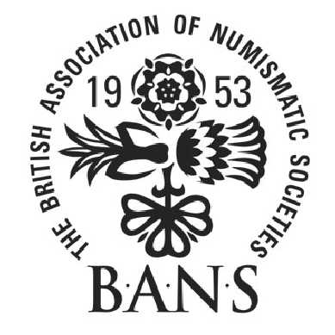

AUTUMN WEEKEND
THE BRITISH ASSOCIATION OF NUMISMATIC SOCIETIES
Stratford-upon-Avon
The Grosvenor Hotel

Friday 20th to Sunday 22nd September 2019

The Autumn Weekend of the British Association of Numismatic Societies this year will take place in Stratford-upon-Avon at the Grosvenor Hotel which is situated a short walk from the centre of the town. It will run over the weekend of Friday 20th to Sunday 22nd September and, as someone who has attended BANS events in the past, or who has been associated with BANS, I very much hope you will be able to join us.

An excellent programme of lectures has been arranged over the three days including, Chris Barker, Dr Joseph Bispham, Dr Andrew Burnett, David Guest and Dr David Symons. A full programme will be available over the coming weeks and the talks will offer a good range of subjects to cater for all manner of interests.

The hotel is no more than a five to ten minute walk from the centre of Stratford, one of the most historic towns in Britain. All the rooms offer en suite facilities and car parking is available at the back of the hotel.

A booking form is enclosed. The full cost of the weekend, which will include en suite accommodation, all meals and the lectures, will be £265 for single occupancy and £390 for a couple. So that we have some idea of the numbers, we would appreciate it if you could let us know if you are going to attend sooner rather than later by telephone, letter or email. A deposit cheque of £50 should be made payable to the British Association of Numismatic Societies and can be sent to me at the contact details provided below.

Where relevant, we would be grateful if you could inform other members of your local numismatic society about this event.

So that we have some idea of the numbers who are likely to be there, it would be much appreciated if you could let my colleague Virginia Porter know by email or by post if you are planning to attend. Her email address is: virginia.porter@royalmintmuseum.org.uk or you can send the booking form to her at The Royal Mint Museum, Llantrisant, Pontyclun, CF72 8YT

I do hope you will be able to join us.

Best wishes

Dr Kevin Clancy
Director
The Royal Mint Museum

