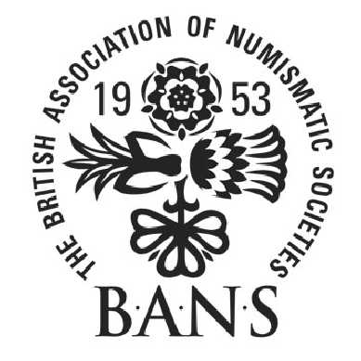
AUTUMN WEEKEND
THE BRITISH ASSOCIATION OF NUMISMATIC SOCIETIES
The Lion Hotel, Shrewsbury

Friday 7th September to Sunday 9th September 2018

Friday 7th September
15.00 – 17.30 Registration at the Lion Hotel
18.00 – 18.45 Tim Jenkins, A Sallopian miscellany – An introduction to Shrewsbury and Shropshire
19.15 Dinner

Saturday 8th September
7.45 – 9.00 Breakfast
9.15 – 10.00 Phillip Timmins, The Jacobite coinage of James II’s Irish campaign, 1689 to 1691
10.00 – 10.45 Chris Shaw, Deltiology numismatica
10.45 – 11.15 Coffee break
11.15 – 12.00 Robin Eaglen, The state of numismatics in Britain
12.00 – 12.45 Antony Dufort, Why me? A sculptor designs a definitive coin for the
Royal Mint
13.00 – 14.00 Lunch
14.00 – 19.00 Free time to explore Shrewsbury
19.00 Dinner (a raffle will be held)

Sunday 9th September
7.45 – 9.00 Breakfast
9.15 – 10.00 Steve Bentley, Currency crisis, makeshift silver coinage of Napoleonic times
10.00 – 10.45 William MacKay, Southern English coinage in the age of Burgred c.850-75
10.45 – 11.15 Coffee break and vacate rooms
11.15 – 12.00 Paul Withers, The perils of (numismatic) self-publishing
12.00 – 12.45 Chris Comber, The pattern shillings of Elizabeth I bearing the mintmark ‘key’.
12.45 – 13.00 Closing remarks
13.00 – 14.00 Lunch
14.00 Depart

